Duaa shehada - 11716595

The generated output :

Here will be shown the requests and results .also, the affected files, and the response time.

Info request :

At the first I send a request to the server, the load balancer chooses the catalog2 server.

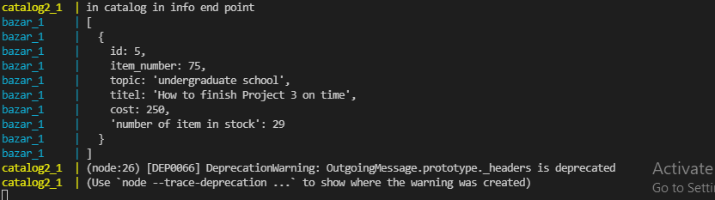

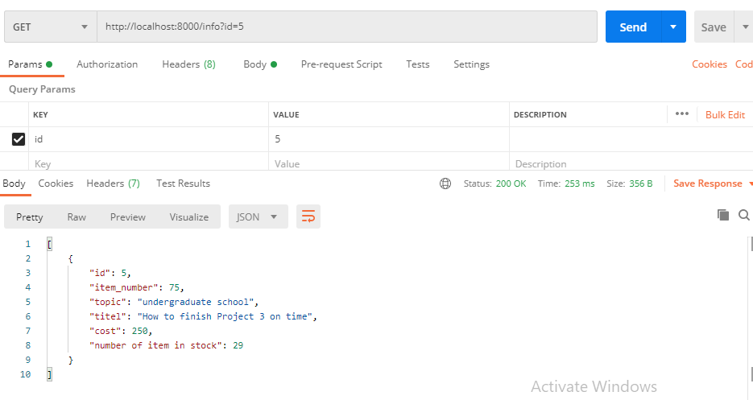

As seen the response time is: 253ms

And because the cache is set to a specific time which is 35sec. when I send the next request the time is over than 35sec. so, it sends the message to the server again.

The load balancer chooses the catalog server this one.

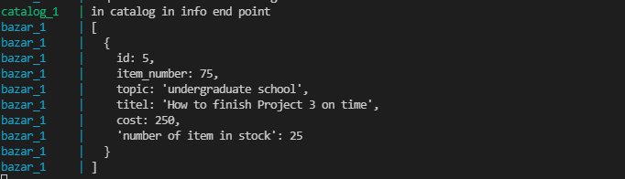

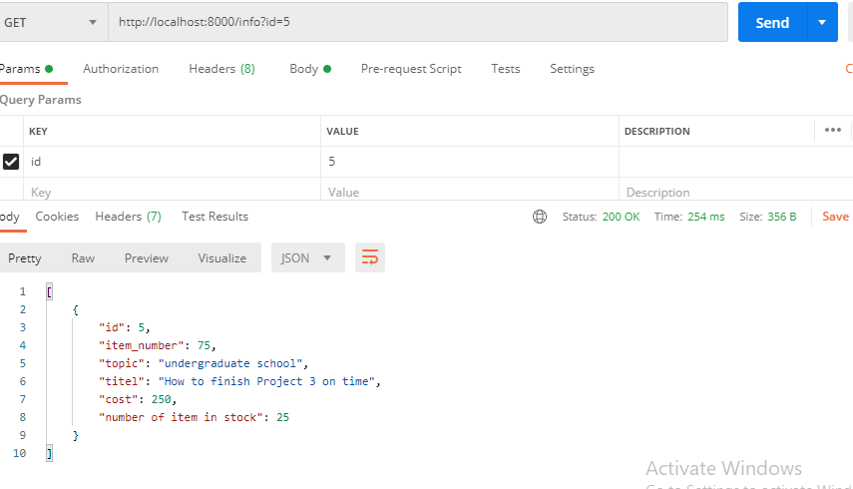

The response time is: 254ms

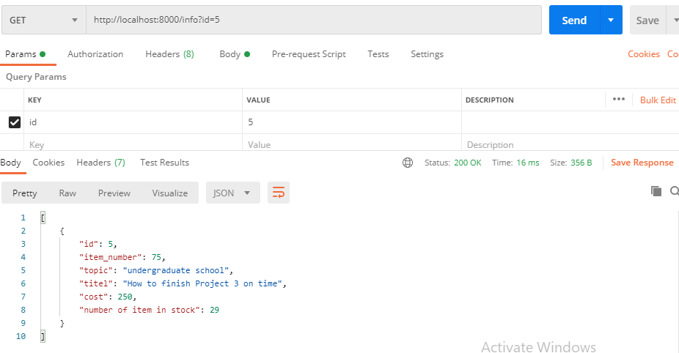

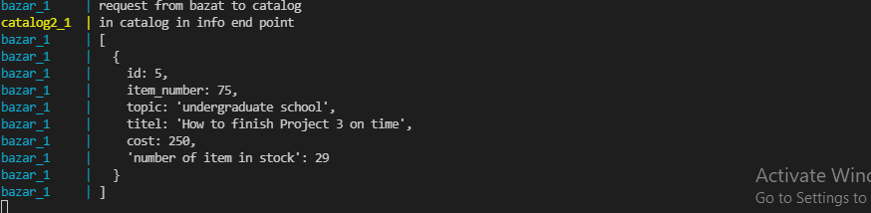

Here , as shown when the result is in the cache, the response time is: 15ms

And it is clear that there is no need to send the request to the server.

Search request :

Same as in info request.

The difference in response time shown

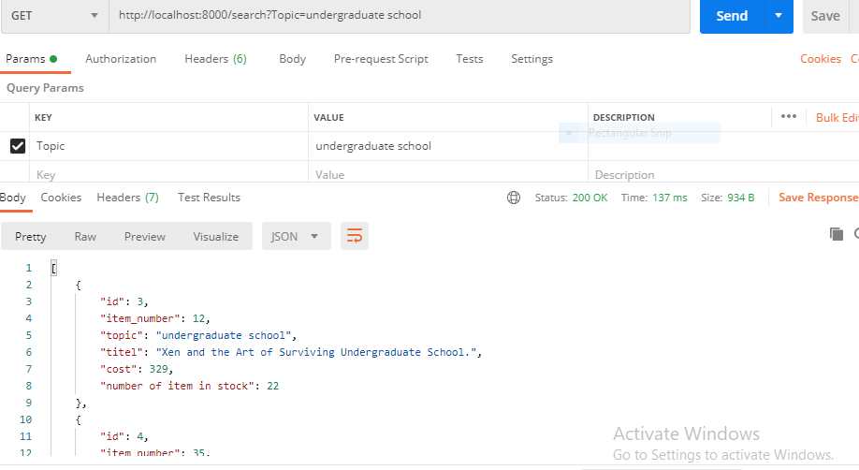

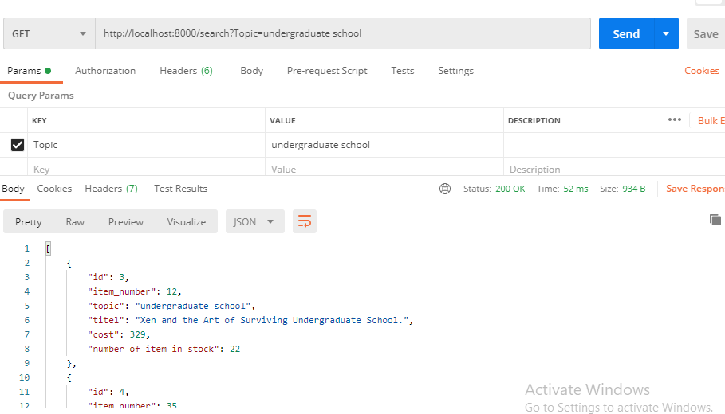

Purchase request :

Here will be a focus on the cache and the consistency both

As seen in the info request the "number of items in stock" = 26

Before the purchase request

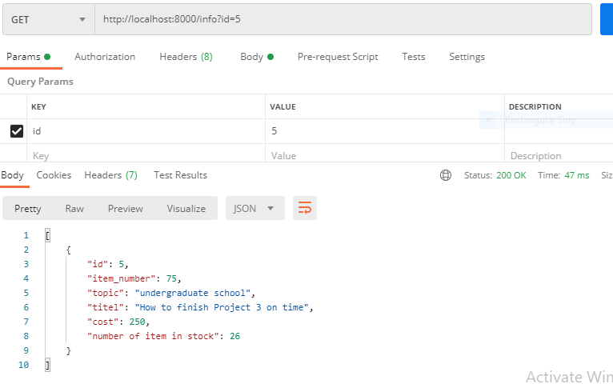

Then . here the purchase request

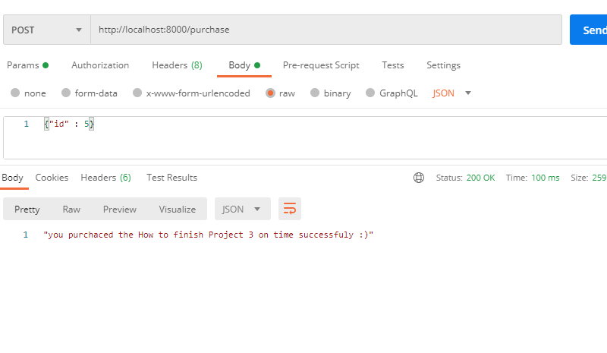

Here, the info request that appears with 25 items in stock, and the response time show that it is requested to the server not from the cache because there is invalidate msg send to the cache and delete this item from it.

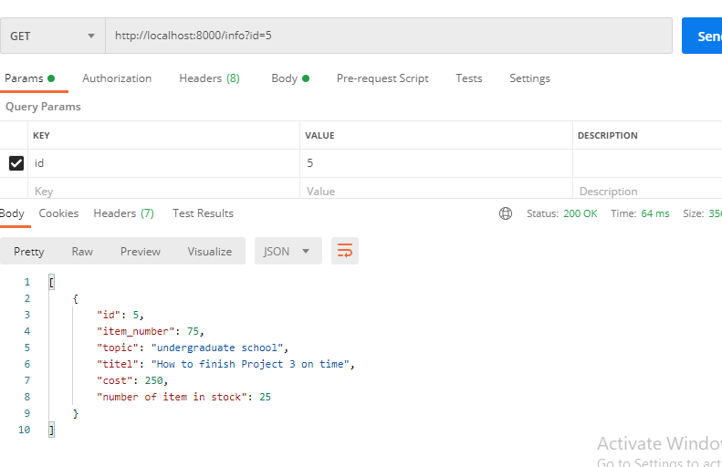

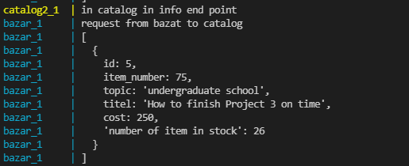

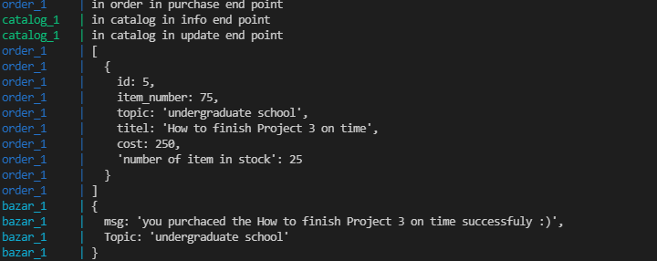

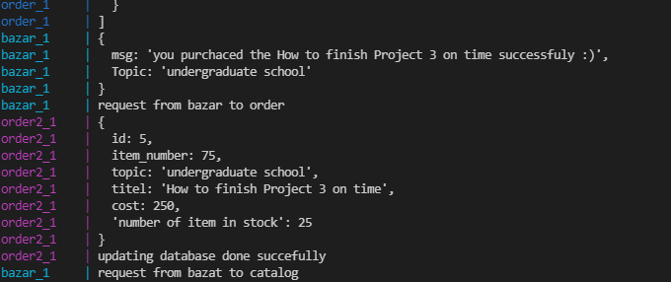

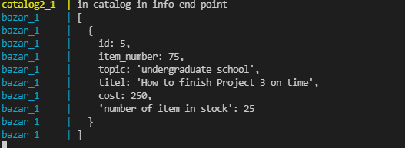

From the above photos, we see how each request goes in the servers and notice that the load balancer works well.

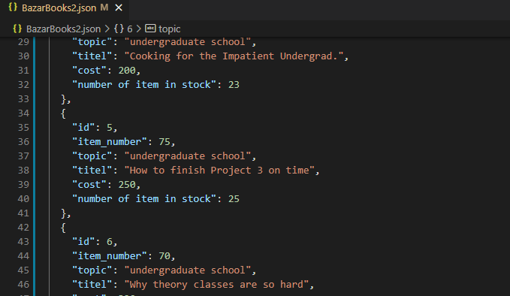

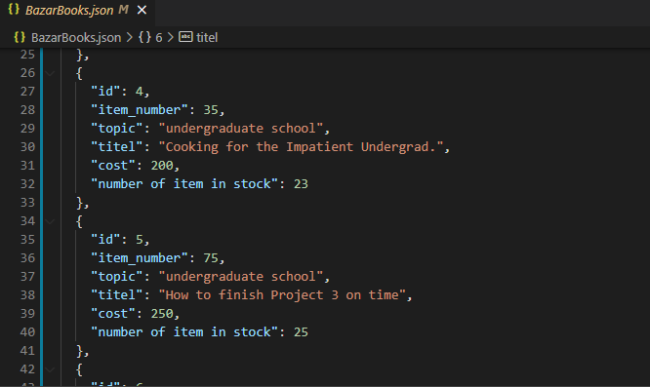

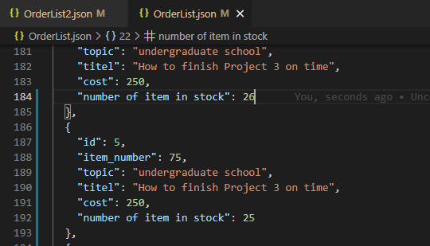

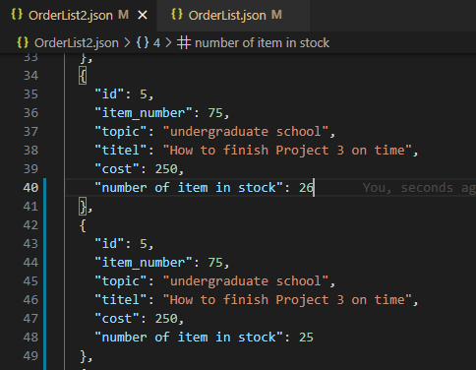

Here is the updated data in the files and shows that the consistency of the database in all servers works well.